**Welcome to Aim Academy Math**

Thank you for your interest in Algebra I this year. To allow me to better understand your math background, please complete the application and placement test below. Upon completion, please email this form back to me at [mrscamp4@gmail.com](mailto:mrscamp4@gmail.com). Once I approve your application, you may proceed with registration at Aim Academy.

|  |  |
| --- | --- |
| **Student Name** |  |
| **Gender** |  |
| **Age** |  |
| **Birthday** |  |
| **Grade Next Year** |  |
| **Student Email** |  |
| **Mailing Address** |  |
| **Parent Name(s)** |  |
| **Parent Email(s)** |  |
| **Parent Phone(s)** |  |
| **Student Interests** |  |

**Please list any previous coursework in math, starting with Pre-Algebra. Complete as much information as you can.**

|  |  |  |  |
| --- | --- | --- | --- |
| **Course Name** | **Year(s) Taken** | **Curriculum Used** | **Grades Earned** |
| Pre-Algebra (Transition Math) |  |  |  |
|  |  |  |  |
|  |  |  |  |
|  |  |  |  |

**Aim Academy Algebra 1 Placement Test – Answer Sheet**

Please complete the placement test without the use of books or calculators and place your answers below:

|  |  |
| --- | --- |
| **#** | **Answer** |
| **1.** |  |
| **2.** |  |
| **3.** |  |
| **4.** |  |
| **5.** |  |
| **6.** |  |
| **7.** |  |
| **8.** |  |
| **9.** |  |
| **10.** |  |
| **11.** |  |
| **12.** |  |
| **13.** |  |
| **14.** |  |
| **15.** |  |
| **16.** |  |
| **17.** |  |
| **18.** |  |
| **19.** |  |
| **20.** |  |

**Aim Academy Algebra 1 Placement Test**

Please place your answers on the answer sheet. Books and calculators are not permitted for this test.

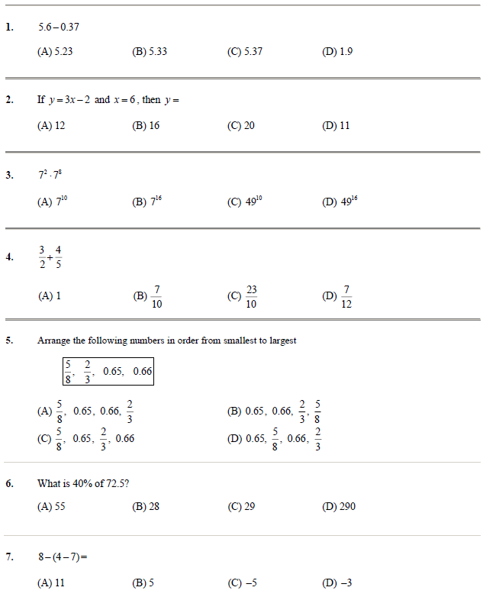

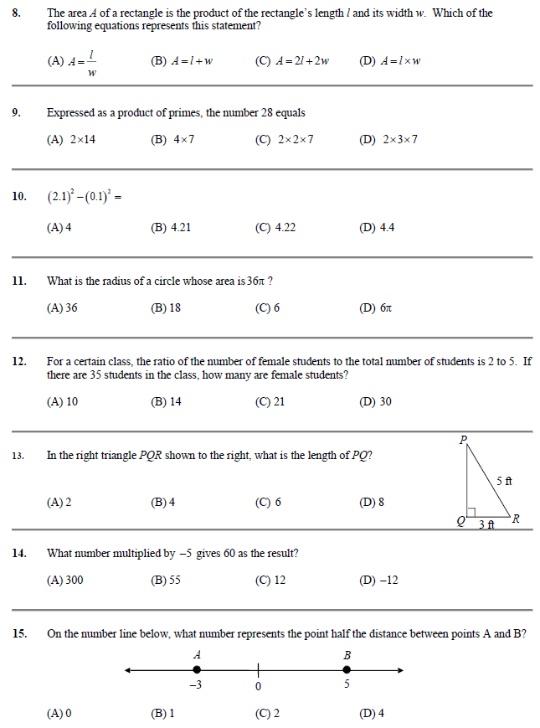

**16.** Simplify completely: 

(A)  (B)  (C)  (D) 

**17.** Simplify: 

(A)  (B)  (C)  (D) 

**18.** A number was multiplied by –4 and decreased by 6. If the result was 34, what was the number?

(A) 7 (B) –7 (C) 10 (D) –10

**19.** Solve: 

(A) 12 (B) $\frac{45}{4}$ (C) 16 (D) 9

**20.** Find the least common multiple of 8, 12, and 16.

(A) 4 (B) 32 (C) 48 (D) 1536